**Project Planning Phase**

**Project Planning Template (Product Backlog, Sprint Planning, Stories, Story points)**

|  |  |
| --- | --- |
| Date | 11-02-2024 |
| Team ID | SWTID1720167264c |
| Project Name | Cab Booking App |
| Maximum Marks | 4 Marks |

**Product Backlog, Sprint Schedule, and Estimation (2 Marks)**

Use the below template to create product backlog and sprint schedule

| **Sprint** | **Functional Requirement (Epic)** | **User Story Number** | **User Story / Task** | **Story Points** | **Priority** | **Team Members** |
| --- | --- | --- | --- | --- | --- | --- |
| Sprint-1 | User Registration | USN-1 | As a user, I can register for the application by entering my email, password, and confirming my password. | 2 | High | Harshavardan C R |
| Sprint-1 | User Registration | USN-2 | As a user, I will receive a confirmation email once I have registered for the application | 1 | High | Nishanth P |
| Sprint-1 | User Login | USN-3 | As a user, I can log into the application by entering email & password | 1 | High | M Vishnu |
| Sprint-2 | Location services | USN-4 | As a user, I can set my pickup location using GPS or manual entry | 3 | High | Nandam SakethRam |
| Sprint-2 | Ride Booking | USN-5 | As a user, I can search for available cabs near my location | 3 | High | Harshavardan C R |
| Sprint-3 | Ride Tracking | USN-6 | As a user, I can track my assigned cab in real-time | 5 | Medium | Nishanth P |
| Sprint-3 | Payment Integration | USN-7 | As a user, I can pay for my ride using various payment methods | 5 | High | Nandam SakethRam |
| Sprint-4 | User Rating | USN-8 | As a user, I can rate my ride experience after completion | 2 | Low | M Vishnu |
| Sprint-4 | Ride History | USN-9 | As a user, I can view my past ride history and details | 3 | Medium | Nandam SakethRam |

**Project Tracker, Velocity & Burndown Chart: (2 Marks)**

| **Sprint** | **Total Story Points** | **Duration** | **Sprint Start Date** | **Sprint End Date (Planned)** | **Story Points Completed (as on Planned End Date)** | **Sprint Release Date (Actual)** |
| --- | --- | --- | --- | --- | --- | --- |
| Sprint-1 | 20 | 3 Days | 4 July 2024 | 6 July 2024 | 18 | 7 July 2024 |
| Sprint-2 | 20 | 3 Days | 7 July 2024 | 9 July 2024 | 20 | 9 July 2024 |
| Sprint-3 | 20 | 2 Days | 10 July 2024 | 11 July 2024 | 17 | 12 July 2024 |
| Sprint-4 | 20 | 2 Days | 12 July 2024 | 13 July 2024 | 19 | 13 July 2024 |

**Velocity:**

Sprint-1: 18 story points completed in 3 days

Sprint-2: 20 story points completed in 3 days

Sprint-3: 17 story points completed in 2 days

Sprint-4: 19 story points completed in 2 days

Total Story Points Completed: 18 + 20 + 17 + 19 = 74 Total Number of Sprints: 4

Average Velocity = Total Story Points Completed / Number of Sprints = 74 / 4 = 18.5

Total project duration: 10 days (July 4 to July 13, inclusive)

Average Daily Velocity = Total Story Points Completed / Total Days = 74 / 10 = 7.4 story points per day

**Burndown Chart:**

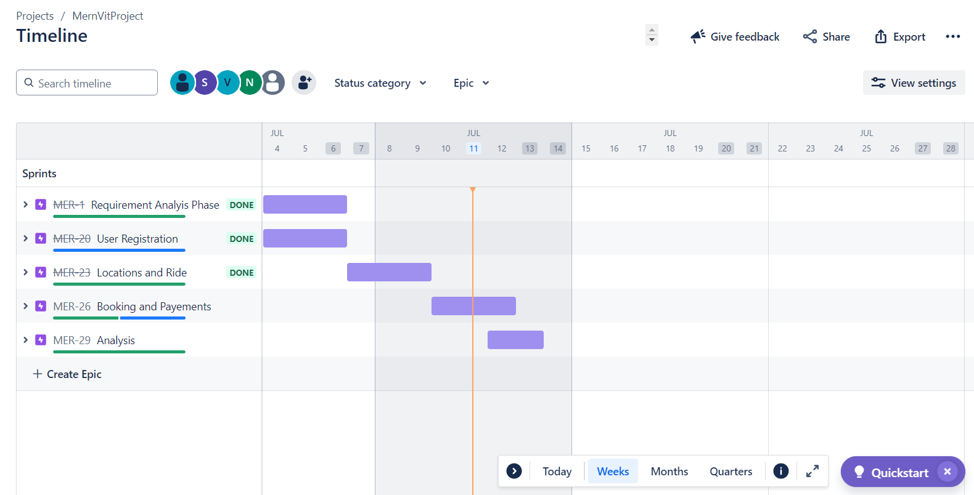

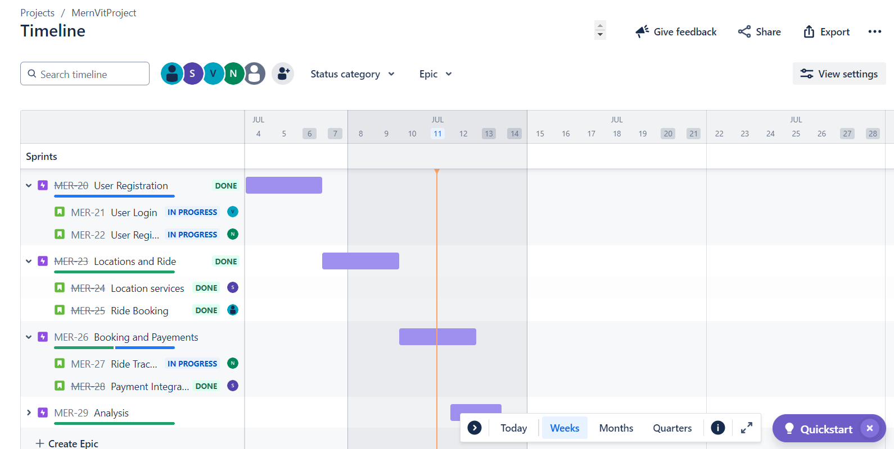

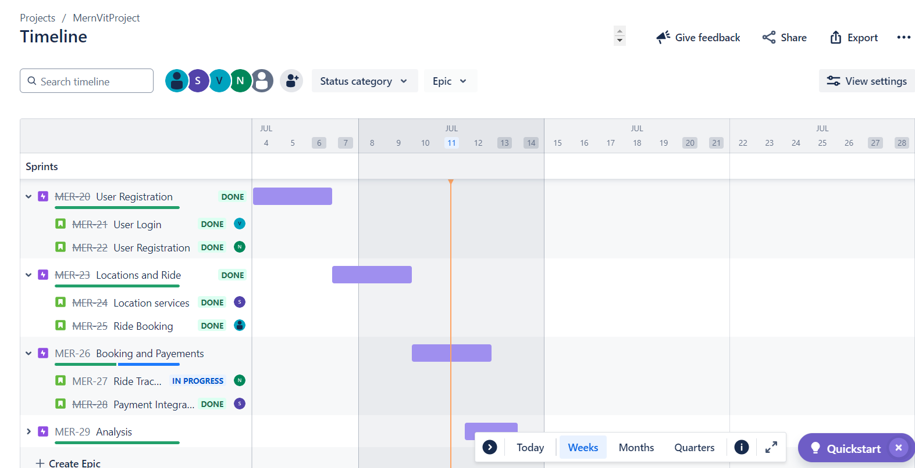

A burndown chart is a graphical representation of work left to do versus time. It is often used in agile[software development](https://www.visual-paradigm.com/scrum/what-is-agile-software-development/) methodologies such as [Scrum](https://www.visual-paradigm.com/scrum/scrum-in-3-minutes/). However, burn down charts can be applied to any project containing measurable progress over time.

[**https://www.visual-paradigm.com/scrum/scrum-burndown-chart/**](https://www.visual-paradigm.com/scrum/scrum-burndown-chart/)

[**https://www.atlassian.com/agile/tutorials/burndown-charts**](https://www.atlassian.com/agile/tutorials/burndown-charts)

**Reference:**

[**https://www.atlassian.com/agile/project-management**](https://www.atlassian.com/agile/project-management)

[**https://www.atlassian.com/agile/tutorials/how-to-do-scrum-with-jira-software**](https://www.atlassian.com/agile/tutorials/how-to-do-scrum-with-jira-software)

[**https://www.atlassian.com/agile/tutorials/epics**](https://www.atlassian.com/agile/tutorials/epics)

[**https://www.atlassian.com/agile/tutorials/sprints**](https://www.atlassian.com/agile/tutorials/sprints)

[**https://www.atlassian.com/agile/project-management/estimation**](https://www.atlassian.com/agile/project-management/estimation)

[**https://www.atlassian.com/agile/tutorials/burndown-charts**](https://www.atlassian.com/agile/tutorials/burndown-charts)